

**Monetary policy, asset prices and distribution**

Speech given by

Ben Broadbent, Deputy Governor for Monetary Policy, Bank of England

At the Society of Business Economists Annual Conference 23 October 2014

I would like to thank Alina Barnett for research assistance and I am also grateful for helpful comments from other colleagues in particular from Richard Harrison, David Learmonth and Gareth Ramsay.

The views expressed are my own and do not necessarily reflect those of the Bank of England or other members of the Monetary Policy Committee

A few years ago, I used to take the overground train into work. The line was cluttered with stations – mine was barely 400 yards on from the previous stop. So you can understand why my fellow commuters were less than convinced one morning when, seeking to explain why our train was 20 minutes overdue, the driver said this was “because we left the last station late”. It raised a smile. But it wasn’t an explanation.

I confess I have a similar reaction to accounts that seek to “explain” low interest rates, and the behaviour of asset prices more generally, solely by reference to what central banks have done. This is especially true when those accounts go on to attribute significant and lasting redistributive effects to these policies. For example, and at least when they happen to be going up, it’s quite common to hear that equity markets are benefiting from “easy money”.

But independent changes in monetary policy will ultimately be reflected in inflation and, despite a decline in interest rates that’s now gone on for 20 years, inflation has remained pretty close to target, throughout the developed world (Chart 1). This suggests that, rather than causing the decline themselves, central banks have instead been accommodating a deeper downward trend in the “natural” or “equilibrium” rate of interest. That is not a trivial matter: if they had failed to track this trend, policy would have been too tight and inflation and output too low.

And although stocks performed well through the early part of that decline, for much of it they’ve not done so. Chart 2 plots the yield – inversely related to the price – on indexed gilts and UK equities. Through the 1990s these two markets tended to move together and, in price terms, generally upwards. Since around 2001, however, their yields have diverged. Equities have significantly underperformed bonds. This suggests that, over that past decade or so, the forces depressing the natural rate of interest have also been increasing the extra premium required of risky assets. What I want to do today is say something about the causes of these trends and (in only the broadest possible terms) their implications for the distribution of wealth and income.

None of this will be particularly novel. Economists and central bankers were remarking on the low level of real interest rates as early as 20051. The MPC discussed the factors behind the more recent decline, since the financial crisis, in the February 2014 Inflation Report, in the context of its forward guidance. My colleague David Miles went through some of these arguments in more detail in a speech in February this year. The debate about “secular stagnation” has also focussed a lot of attention on the issue.

The only wrinkle here is to distinguish those factors that are good for risky assets from those that are bad – and, in doing so, to say something about distributional effects. I also want to caution against mistaking cause for effect and in particular, when it comes to asset prices, putting central banks at centre stage. Autonomous changes in monetary policy certainly can have an impact on asset prices. But that does not mean they’re the

1 Bernanke (2005)

only thing that actually does so. Over time, trends in real asset prices are determined by real (non-monetary) forces: we may occasionally be prominent actors but it’s someone else who’s written the script.

# Chart 1 Inflation close to target despite protracted decline in short term interest rate

Source: Bank of England and ONS

# Chart 2 Lower bond yields not always associated with higher equity prices

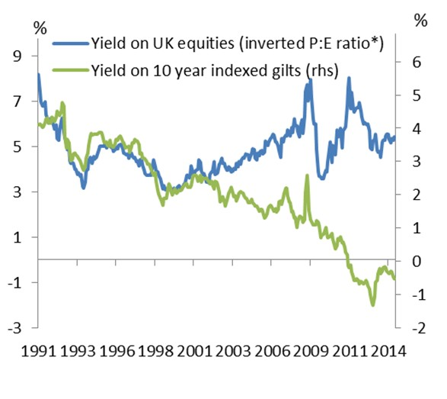Note: * adjusted for changes in leverage2 Source: Bank of England and Datastream

# The decline in the natural rate of interest

At around the time that inflation targeting began, the economist John Taylor proposed a simple representation of rate-setting by the US Fed – the so-called “Taylor rule”. This suggested that variations in real short rates were well explained, empirically, by movements in the “output gap” and inflation. Allowing for these real short rates looked relatively stable.

The word “rule” wasn’t meant prescriptively. In this context it simply meant “reaction function” – a description of the way US policy rates had in practice, and over a particular period of time, responded to the economy. But as the concept took hold, many began to interpret the relationship not just as a description of what central banks had been doing but as an indicator of what they should do. In particular, the Taylor rule cemented a view that only cyclical factors could justify deviating from a particular level of the policy rate. In the UK, for example, there was a commonly held view in the mid-1990s that, as long as the economy was operating at potential and inflation was on target, real interest rates would necessarily have to settle at a rate

2 The blue line is actually E/V, where E is earnings and V the total value of the firm, net debt as well as equity. Unlike E/P, and at least if the Modigliani-Miller neutrality result applies, E/V is invariant to changes in leverage. For a given total value V, higher leverage raises earnings per share and the E/P ratio.

of 3% or so in real terms, roughly their average over the previous few years. This would imply a “neutral” nominal rate of close to 6%.

“Neutral” doesn’t mean constant, however. It means the level of interest rates that, across the world, ensures the supply and demand for finance – desired levels of saving and investment – are brought into line3

(Chart 3).

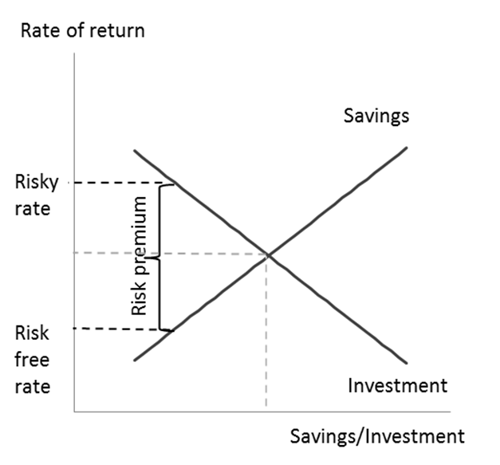**Chart 3 Stylised supply and demand for finance** And in principle, any number of things – any

number of real economic disturbances – can move that rate around. An autonomous rise in the supply of finance, for example, would tend to depress real interest rates and the expected returns on all assets, quite independently of monetary policy. More optimism about the future, increasing the demand for investment funding, would push up real interest rates. An increase in the perceived degree of risk, increasing the wedge between the required return on risky assets and the risk-free rate, can push up the first but depress the second (using a simple model of asset prices I’ll present below some stylised simulations that make these points).

So the notion that real interest rates only vary because the output gap moves around, or because central banks are making mistakes, doesn’t square with theory. Nor does it make much sense empirically, particularly over the past twenty years:

First, as I said in the introduction, inflation has been relatively stable. Anyone who believed in the mid-1990s that the neutral policy rate was fixed at 6% (in nominal terms) would have viewed with some alarm the sharp decline since then. Bank Rate has now been over 5% points below the estimates of the neutral rate that prevailed in the 1990s, for well over five years – a period far longer than the lags supposed to exist between policy changes and their effects. Taking into account any additional impact of quantitative easing (QE) the predicted result would presumably have been a cyclical boom in output and ever-rising inflation, throughout the developed world. That’s not what’s occurred.

3 I’ve been a bit imprecise with terminology here, using “natural”, “equilibrium” and “neutral” interchangeably. By the first two I mean the real short-term interest rate that would prevail if prices and wages were fully flexible (Woodford (2003)). Occasionally people distinguish the short and longer-term level of this rate (using “natural” and “equilibrium” respectively). Neutral is the term usually reserved for the rate that would keep the economy cyclically stable over the longer term – the intercept in the Taylor rule – though in many settings this is the same as the natural rate.

Second, the decline in short-term real interest rates has been accompanied by a similarly steep fall in longer- term real interest rates. The yield on the 10-20 year portion of the indexed gilt curve, for example, was 4% in the mid-1990s; by the end of that decade it had dropped to barely 2%; on the eve of the financial crisis, in mid-2007, it was less than 1%; today it is -0.3% (Chart 4). This is significant because, just as a matter of principle, it’s hard to see how pure monetary disturbances – including any independent decisions of monetary policy makers – can have very enduring influences on real things, including real interest rates (that’s particularly true for monetary authorities in relatively small and open economies like the UK). So they’re unlikely to have had much bearing on real forward rates.

Third, even if you doubt these basic principles, the data show that, where we’re able to isolate autonomous (or at least unexpected4) shifts in official interest rates, they don’t seem to produce any reaction in

longer-term real forward rates (Chart 5).

# Chart 4 Real interest rates have also declined at longer horizons

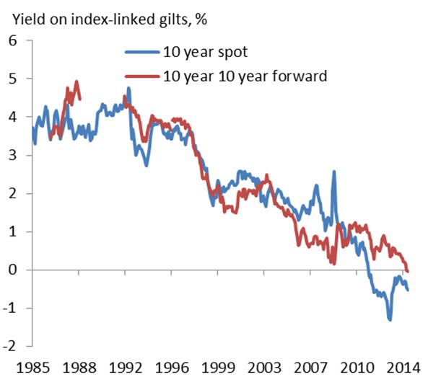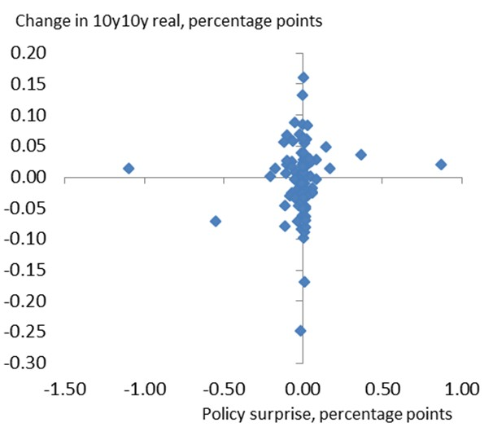

**Chart 5 Longer term yields insensitive to policy surprises**

Source: Bank of England Source: Bank of England and Bank calculations

QE is a different matter. As has been well documented elsewhere, announcements of asset purchases did have statistically significant effects on longer-term interest rates. Work at the Bank suggests that the combined effects of the various stages of QE reduced 10-year gilt yields by as much as 100bp. But it’s not clear for how long that effect has persisted: there are reasons to believe that asset purchases have a greater impact when markets are more illiquid, and have less capacity to absorb the flows. Most of the decline in longer-term real interest rates occurred before the crisis. And, in any event, the first point above still applies:

4 A policy surprise is defined here as the difference between the announced Bank rate and a proxy for market expectations embodied in meeting-to-meeting interest rate swaps on the day of the MPC decision.

judging by the subsequent behaviour of inflation, QE looks simply to have brought forward a decline in real interest rates that would have occurred anyway, only more painfully so. As the Bank of England explained in a Quarterly Bulletin article a couple of years ago, without QE we’d have experienced higher unemployment, lower wages and lower inflation. It’s hard to see bond yields rising in such an environment.

In this respect it’s interesting to look at a passage from Keynes’s Treatise on Money, written in the teeth of the Great Depression in December 1930:

*We cannot hope for a complete or lasting recovery until there has been a very great fall in the long-term rate of interest throughout the world … Yet [that] is likely to be a long and a tedious process, unless it is accelerated by deliberate policy. Of specific remedies two [are] appropriate. The Bank of England and the Federal Reserve Board might reduce the rate of interest to a very low figure, say ½ per cent. At the same time these institutions should pursue open-market operations à outrance. That is to say, they should buy long-dated securities either against an expansion of Central Bank money or against the sale of short-dated securities until the short-term market is saturated.*

So QE certainly isn’t a novel idea (in fact the US Fed conducted large scale asset purchases in 1932, something that Milton Friedman5 later suggested was critical in stabilising the economy later that year). And, as Keynes suggests, the purpose was to “accelerate” a decline in long-term interest rates that would otherwise have been a “tedious” process.

# Some stylised experiments affecting the natural interest rate

So if it’s not monetary policy, what might have caused the long decline in the real risk-free rate of interest in the past twenty years or so, both before and since the financial crisis? Chart 3 provides a basic visual framework for thinking about these things. What follows, based on a simple asset-pricing model, gives a slightly more quantitative flavour.

Any such model will generally allow for three sorts of influences on asset prices: the underlying discount rate (the extent to which people care less about the future than the present), expected economic growth and the degree of uncertainty about that growth. The particular model I’m using here allows for two sorts of uncertainty – a generalised, two-sided risk and, on top of that, the possibility of a large downside hit to growth6.

5 Friedman and Schwartz (1963)

6 The model, developed by the economist Robert Barro, and based on an earlier idea by Rietz, allows for the effects of one-sided tail risk – the potential for macroeconomic “disasters” – as well as more conventional, two-sided uncertainty (Barro (2009)). The downside

skew to growth reduces the risk-free interest rate and pushes up the required return on risky assets. I used this model to speculate about the causes of low investment in a speech a couple of years ago (Broadbent (2012)).

The first of these terms is connected with saving. All else equal, a lower discount rate means people want to save more – at the margin, they’re prepared to tolerate a lower rate of return on any asset. In terms of

Chart 3 you can think of this as a rightwards shift in the saving schedule. In the simple model, the effect of a 1%-point drop in the discount rate on the risk-free interest rate and the value of equities is shown in

Chart 6(a). Interest rates fall and, at least on impact, equity prices jump. This is because the present value of future profits increases, not because the profits themselves do so. From that point on, expected returns on all assets would be lower.

Higher saving was often touted as the possible reason for lower interest rates ahead of the crisis. At the time the argument was first made, during the early part of the last decade, the suggested “glut” in saving was often associated with the fast-growing east Asian countries. Some economists, notably Thomas Piketty, have suggested that, because the rich generally save more, widening income inequality may have contributed to the trend. Others have pointed out the importance of demographic factors.

Whatever the underlying cause, the important point is that higher desired saving would tend to have a similar impact on the price of all long-dated assets, whatever their risk. That’s why it looks like a good candidate for the co-movement between equities and bonds evident in the early (pre-2001) part of Chart 2.

The other determinants of asset prices – the level of, and uncertainty about, future economic growth – tend to have differing effects on the two asset classes. Lower expected growth will reduce investment demand and, by shifting that schedule to the left (Chart 3), will tend to reduce the equilibrium risk-free interest rate. Future profits will be discounted more generously, as before, but now the profits themselves will be lower. So despite a lower interest rate, and a rise in bond prices, equity prices fall on impact (Chart 6(b), which simulates a 1%-point decline in expected future growth). They also return less from that point on.

Qualitatively, increases in uncertainty have similar effects – they reduce equilibrium interest rates and depress equity prices (Charts 6(c) and 6(d)). But their sizes are rather different. Changes in two-sided uncertainty don’t do that much (6(c)); by contrast, small rises in the perceived chance of very bad economic events can have powerful effects on the risk-free interest rate7. Intuitively, this makes sense: an asset whose payouts are immune to such disasters are valuable. Even if that downside risk rises by only a little, people are prepared to pay quite a bit more for – and to tolerate lower returns on – the “safe haven” of government debt. And I think it’s plausible, at least, that an increasingly negative skew to global growth expectations might help to explain the divergence between equity and bond yields in Chart 2.

7 This obviously depends on the sizes of the changes involved. Chart 6(c) simulates the effect of increasing the standard deviation of annual growth from 2% to 3%. Given that, even over the past twenty years, the true figure – for both world and UK growth – has been around 2%, that’s a fairly significant rise. Chart 6(d) shows what happens when you raise the perceived probability of an economic “disaster” by only 1% point (from 3% to 4%) and, although the simulated disaster is indeed very bad (a 20% drop in output) it’s not out of line with some of those that have occurred in the past (Barro 2009)).

# Chart 6a Stylised effect of drop in discount rate Chart 6b Decline in expected growth

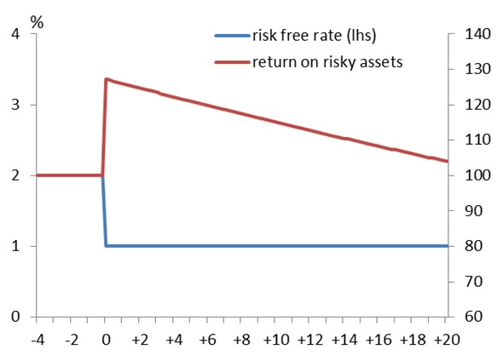 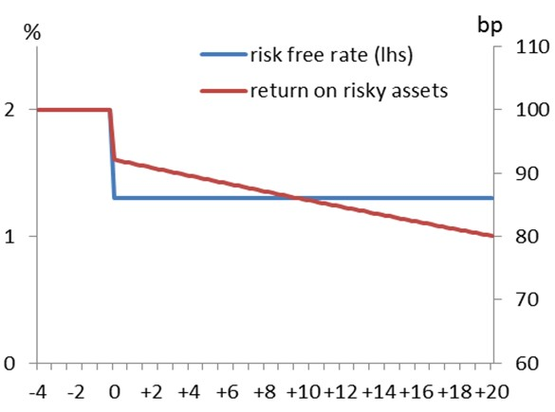

**Chart 6c Rise in two sided uncertainty Chart 6d Rise in downside tail risk**

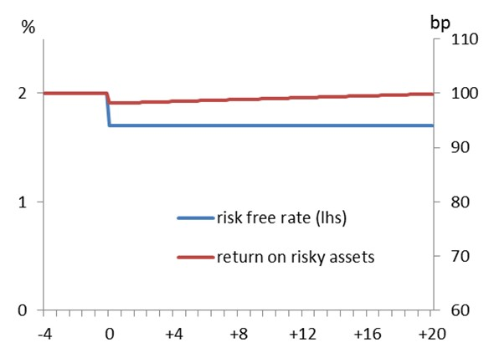 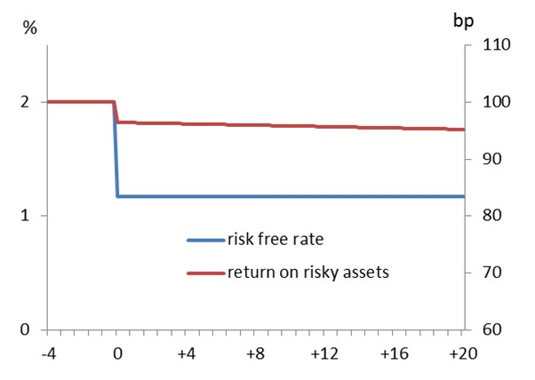

Now these are extremely stylised simulations and one should obviously take them with a pinch of salt. Even within this basic framework there are plenty of other things that might have reduced the equilibrium risk-free interest rate. For example – and of particular relevance since the crisis – saving might be forced higher by the need to deleverage, in both public and private sectors8. In addition to elevated risk premia between equity and bond yields, retail lending rates may be affected by lower liquidity in some wholesale financial markets9. The debate about “secular stagnation” – the idea that the equilibrium real interest rate is sufficiently negative to be out of reach of monetary policy (given the zero lower bound) – has brought forth more potential factors still, including population aging, a shift toward less capital-intensive production and institutional changes that have increased the demand for safe assets10.

8 Eggertson and Krugman (2012) develop a model where deleveraging pressure has very protracted effects on (ex ante) saving and on equilibrium real interest rates.

9 David Miles (2014) points out the significant widening in the spread between interest rates on retail loans and Bank rate since the crisis. Part of this might reflect the more generalised widening in risk premia but it could also reflect factors specific to the banking

system.

10 Some of these institutional changes – requirements for banks to hold great quantities of liquid assets, for example – post-date the crisis; others (changes in the accounting for pension fund liabilities) have been in place for longer. A good source for these and other

arguments is an ebook on secular stagnation published earlier this year by VoxEU (2014).

But what all these possibilities have in common is that they’re real economic changes – they have consequences for, but do not originate in, monetary policy. Those consequences are significant. If monetary authorities fail to recognise a decline in the underlying, natural rate of interest, leaving the official interest rate unchanged amounts to a tightening in policy. That’s precisely the charge levelled by some economists at the US Fed in the 1930s. It’s also why it was crucial, for the sake of the global economy, that official interest rates in developed economies were cut as sharply, and as promptly, as they were in 2008 and 2009. But one should see those cuts, and the earlier declines that preceded them, in context: they took place against a backdrop of a falling natural, or equilibrium rate.

# Some remarks about distributional effects

As long as assets are unevenly spread across the population, shifts in their prices will have redistributive effects. Let me now say something about what those might have been. I’ll make only a few, and very broad points.

First, as regards the distribution of wealth, one of the main sources of unevenness is age. There is certainly considerable variation within age groups. In Chart 7, a snapshot taken from the ONS’s first Wealth and Asset Survey (2006), the vertical lines are interquartile ranges for each 10-year age bracket. Among households headed by 45-54 year olds, for example, those 25% from the top had over £200,000 more in net wealth than those 25% from the bottom of the distribution.

But there is also significant variation across age groups. Even relatively wealthy 25-year-olds have significantly less in the way of net assets than the average 50-year-old. This means that, during the first phase of the decline in real rates, when all asset prices were rising, it was generally older people who benefited the most. Anyone who, in the mid-1990s, happened already to own a house, or whose pension was already well funded, would have benefited materially from these trends. Chart 8 plots the age profile of net wealth in 1995 versus that a decade later11. It steepened considerably.

11 The numbers in Chart 9, which was published in a recent Quarterly Bulletin article by Phil Bunn and May Rostom, are derived from the British Household Panel Survey. This is less detailed than the ONS’s Wealth and Asset Survey but it goes back further.

# Chart 7 Age an important determinant of net wealth

**Chart 8 That much more important after mid- 1990s**

Source: IFS calculations using Wealth and Assets Survey 2006/08 Source: British Household Panel Survey (BHPS) and Bank

calculations

Second, the implications of the trends in more recent years, during which bonds have done well but equities relatively poorly, are obviously more complicated. It depends on who, precisely, owns which asset. Because the majority are owned by institutions – banks, pension funds and insurance companies – it is hard to trace through the impact of any capital gain to its ultimate beneficiary. One thing worth saying is that, at least in terms of effective wealth, the gainers clearly include those entitled to future payouts from defined-benefit pensions. You can’t sell such an entitlement. But it does offer a guaranteed flow of future income, much like the coupons from an indexed gilt (that’s why DB pension funds are obliged to discount their liabilities using gilt yields and why, in response, they hold significant quantities of government debt). The present value of this income has therefore risen in similar fashion. To the extent they include equities, the value of

defined-contribution (DC) pension funds will have performed less well.

The third point is that none of this need have any bearing on the distribution of income, as opposed to that of wealth. This is an important distinction. To the extent that asset prices rise because the marginal investor is becoming more patient, lowering the discount rate (Chart 6(a)), this reflects a change in the present value of a given stream of income, not in the stream itself.

# Chart 9 Labour share of income relatively stable in UK

Source: ONS and FRED

# Summary

Things are a little more complicated if interest rates have fallen in response to slower growth (6(b)). In that case, anyone who has locked in a future flow of income (coupons on government bonds, for example) will gain relative to others. But if we look at capital income in aggregate, there’s no evidence it’s risen at the expense of wages. Despite significant shifts in real interest rates and asset prices, and whatever their cause, the share of total income going to labour (relative to profits) has remained pretty stable in the UK over the past 30 years12. On the face of it, asset price movements have not resulted in labour taking a lower share of the economic pie (Chart 9).

I read a lot of economic commentary that says (i) interest rates are low because central banks have chosen to keep policy rates low and (ii) this has pushed up the price of risky assets, benefiting only those who happened already to own them. I’m not sure either of these is true.

To be sure, autonomous changes in monetary policy can affect asset prices. If the central bank decided to lower interest rates arbitrarily, for no other reason than that it wanted to, real asset prices would rise. But it’s unlikely the effect would endure for a very long time: the only lasting impact would be on inflation. And, in the real world, that’s not what’s happened – inflation has remained broadly close to target even as real interest rates, long as well as short, have trended downwards. This bears out, for me, that the real task for policy is to understand – and then adapt to – economic forces affecting the natural, or equilibrium rate of interest.13 For

a variety of reasons, and over a long period of time, this underlying rate has been driven remorselessly downwards. An official interest rate that might once have been considered inflationary is now contractionary; failing to adapt to these changes sufficiently quickly would have depressed output and pushed inflation below target. And sharp falls in the equilibrium interest rates – which have probably not yet fully unwound – can be thought of as a significant driver of the substantial cuts in interest rates undertaken by the MPC in 2008 and 2009.

As I say, those forces seem to have been at work for a long time, before as well as since the financial crisis. Over that time they have had differing effects on the performance of risky assets. During the 1990s all asset

12 In contrast to the UK the labour share in the US has declined in recent years (see also Elsby et al (2013)). But, over time, these movements have been uncorrelated with interest rates and most explanations, such as they are, involve more structural changes (see, for example, Karabarbounis and Neiman (2014)).

13 The economist Michael Woodford describes optimal policy exactly in these terms – the task is to set the real short-term interest rate close to its natural, or equilibrium level (Woodford (2003)).

classes did well – bonds and equities alike. At least in terms of wealth, that will have benefited anyone who happened already to own long-dated assets, mostly older people. But over the last 15 years, equities have done poorly. Since 1999 UK and US equities have delivered a real cumulative return of only 2% a year, only a touch higher than term bank deposits and a lot lower than the 4½% average return on long-dated gilts (Chart 10). The implications for the distribution of wealth are therefore more complicated. Either way, it’s not clear there have been any for the broad distribution of income, as between capital and labour (and as opposed to wealth).

The low level of real interest rates has recently fuelled talk of a “secular stagnation”. Whether this situation persists – whether the stagnation in real interest rates really is “secular” – is, quite honestly, anyone’s guess. If forced to have a go myself, I’d say that neutral real rates are likely to stay low for some time yet – with the implication that any rises in official policy rates are likely to be “limited and gradual” – but that, eventually, as the headwinds previously highlighted by the MPC dissipate, they are likely to rise. My instinct is to set more store by the very long-term average for both productivity growth, and real interest rates, than the more recent trends. I am not so pessimistic as to imagine that the best one can do, over the next twenty years, is the negative real return offered by indexed gilts.

But one can’t make these predictions with any great confidence. And if that sounds rather non-committal, then it only underlines the point I’m trying to make. Whatever does cause a sustained rise in real interest rates – a lasting solution to the arrangements of the euro area, perhaps, or renewed optimism about global productivity growth – it is unlikely to be the arbitrary whim of central bankers. Those betting on long-term movements in interest rates will have to work a little harder than just listening to people like me. And that sounds like a good place to end.

# Chart 10 Despite low rates equities have performed poorly over the past 15 years

Source: Bank of England

**References**

**Baldwin, R., and Teulings, C.,** 2014, “Secular Stagnation: Facts, Causes and Cures”, *VoxEU*, <http://www.voxeu.org/content/secular-stagnation-facts-causes-and-cures>

**Bank of England**, 2014, May 2014 Inflation Report, <http://www.bankofengland.co.uk/publications/Documents/inflationreport/2014/ir14feb.pdf>

**Banks J., R. Crawford and G. Tetlow**, 2010, “What does the distribution of wealth tell us about future retirement resources?”, A report of research carried out by the Institute for Fiscal Studies on behalf of the Department for Work and Pensions.

**Barro R.,** 2009, “Rare disasters, asset prices, and welfare costs”, American Economic Review 2009, 99:1, 243–264.

**Bernanke B.**, 2005, “The Global Saving Glut and the U.S. Current Account Deficit”, Remarks at the Sandridge Lecture, Virginia Association of Economists.

**Broadbent B**., 2012, “Costly capital and the risk of rare disasters“, speech given At Bloomberg, London, <http://www.bankofengland.co.uk/publications/Documents/speeches/2012/speech581.pdf>

**Bunn P. and M Rostom**, 2014, “Household debt and spending”, Bank of England Quarterly Bulletin No. 304.

**Eggertson G. and P Krugman**, 2012, “Debt deleveraging and the liquidity trap: a Fisher-Minsky-Koo approach”, The Quarterly Journal of Economics (2012), 1469–1513. doi:10.1093/qje/qjs023.

**Elsby M, B Hobijn and A Sahin**, 2013, “The decline of the US Labour Share”, Brookings Papers on Economic Activity, Fall 2013.

**Friedman M. and A. J. Schwartz**, 1963, “A monetary history of the United States 1867-1960”, National Bureau of Economic Research

**Joyce M., N. McLaren and C. Young**, 2012, “Quantitative easing in the United Kingdom: evidence from financial markets on QE1 and QE2”, Oxford Review of Economic Policy, Volume 28, No. 4, pp. 671-701.

**Karabarbounis L and B Neiman,** 2013, “The global decline of the labor share”, *Quarterly Journal of Economics,* 129(1), 61-103, February 2014.

**Keynes J. M**., 1930,” A treatise on money”, New York, Harcourt, Brace and company.

**Miles, D.**, 2014, “The transition to new normal for monetary policy”, Speech given at Mile End Group, Queen Mary College in London and available at [*http://www.bankofengland.co.uk/publications/Documents/speeches/2014/speech707.pdf*](http://www.bankofengland.co.uk/publications/Documents/speeches/2014/speech707.pdf)

**Woodford M**., 2003, “Interest and prices”, Princeton University Press.